**Letter Of Recommendation**

It is with great pleasure that I write this letter in support of Mr Asadbek Kholdarov for his application to the Master's program in Data Science. As his instructor in multiple subjects, I had the opportunity to witness Asadbek Kholdarov's outstanding academic performance and leadership qualities firsthand. His dedication to learning and ability to excel in both technical and interpersonal areas make them an ideal candidate for advanced study in this field.

Throughout his undergraduate studies in Computer Science, where he graduated with rounding it up to 8/10, Asadbek Kholdarov consistently demonstrated a high level of competence across a variety of demanding subjects. Notably, he earned an impressive 85% in "Web Technologies and Applications" 92% in "Multimedia Technologies" 90% in "Python Programming," and 84% in "Software Engineering" and other subjects earned so impressive. These results not only reflect Asadbek’s strong technical foundation, but also his ability to master complex topics and apply his knowledge to real-world challenges. In addition, his performance in "Individual Excellence & Social Dynamics" 90% highlights his adaptability, emotional intelligence, and leadership capabilities essential for success in a collaborative and dynamic field like Data Science.

What sets Asadbek apart is his commitment to excellence beyond academics. As one of the top 10% of students in his cohort, he demonstrated exceptional leadership as a team leader during various university projects. Whether working on minor assignments or major capstone projects, Asadbek Kholdarov consistently completed tasks on time and encouraged his peers to do the same, fostering a productive and supportive environment. His involvement in volunteering at university events further highlights his strong sense of responsibility and community engagement, traits that are indispensable in both academic and professional settings.

Given his strong technical abilities, leadership skills, and relentless drive for excellence, I have no doubt that Asadbek Kholdarov will excel in the Data Science master's program. I wholeheartedly recommend them for admission and am confident that he will make meaningful contributions to the field and to the academic community at large.

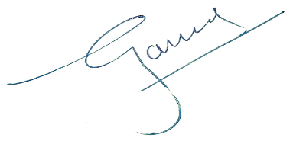

Dr Gaurav Aggarwal

Associate Professor

Department of IT and Engineering

Amity University in Tashkent

Uzbekistan

Email: gaggarwal@amity.uz

Mob: +998-971778645